Steam Ordering System
Object-Oriented Methods CS377
Jonathan Edwards
05/31/2024

Table Of Contents
Section 1: Project Description 3
Section 2: Use Case Diagram 4
Section 3: Class Diagram 6
Section 4: Sequence and Collaboration Diagram 7
Section 5: State Transition and Activity Diagram 10
Section 6: Follow-up Discussion on Use of Object-Oriented and Recap of Design Changes 13
Section 7: Change Control Document 14
Resources 15

Section 1: Project Description
Steam is an online video game store that contains an extensive array of triple A video games, as well as small indie games. As one of the most popular online video game catalogs, steam has a large audience of PC gamers. However, one of the biggest faults of steam is that they only have digital copies for their consumers to purchase. And while it’s nice to have access to these on any computer, it limits Steam's ability to advertise to those who prefer a physical copy of their chosen video game. Additionally, only PC video game players are interested in steam, while there is a whole market of console players that could utilize Steam's vast resources for their multitudes of titles.
In order for an Indie game or solo developer to establish their game on Steam, there is a fairly simple process. However, establishing an indie game for a solo developer on consoles is a bit more of a headache. This is another reason for steam to allow game creators to use steam to distribute physical copies to console players so that everyone can enjoy the game. This would be a benefit to steam, as it would increase their available customer base. And the game developers would have a sole location to launch a video game with ease that can be accessed by anyone interested regardless of the console or computer they play on.
Now, this would create a large change to the infrastructure of Steam. It would need to have warehouses to store the physical copy of the video game discs and cases. This issue is addressed in great detail with a Use Case diagram. The Use Case diagram will help illustrate the process of a customer ordering a game, the handling of payment details, as well as the shipping of the game.

Section 2: Use Case Diagram
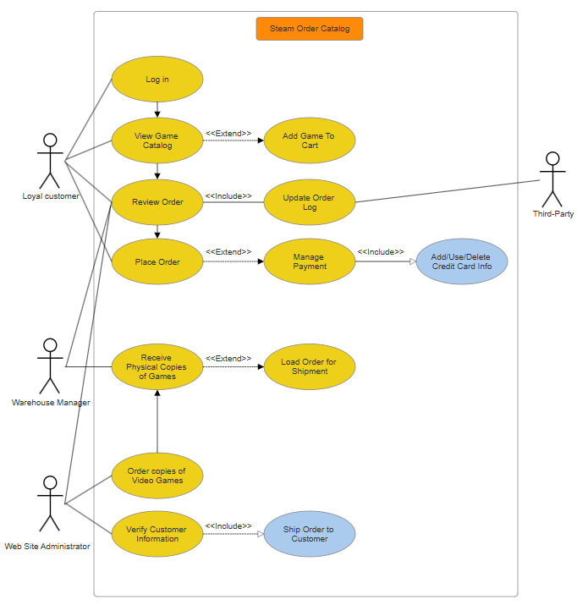

This Use Case diagram identifies the System boundary, the actors and their Use Cases, as well as the relationships they have. The system boundary is the Steam Order catalog. This encompasses the whole process of the system. Within that system, there are 3 actors. The Loyal Customer, the Warehouse Manager, and the Web Site Administrator. Let's go through the Use cases associated with the Loyal customer first.
The customer needs to log into the web store. This will allow access to the customers personal information, like order placements and payment methods. From here, the customer can browse through a selection of video games that are available in the catalog. If the customer wishes, they can add a game to the shopping cart and either continue browsing or review their order. Once the customer is satisfied with reviewing the items they have selected, they can place the order. By placing the order, the customer will be able to manage their payments on file. They can either add a new method of payment, select an existing one, or delete one. Once payment is confirmed by the system, the order will be ready for shipment.
The Web Site Manager will handle the processing of the order placed. This is done by reviewing the customer's order. This will include where to ship the information, as well as verifying the payment information was successful. The Web Site Manager will also ensure that there are available games in the warehouse for the customers to order and receive in a timely manner. This will be done by ordering the physical copies of the video games ahead of time and keeping stock of said games until they are ready to be shipped by the Warehouse Manager.
The Warehouse Manager will receive and unload the physical copies of the video games ordered by the Web Site Administrator. In addition to this, they will prepare the order that the customer has placed, and load the order so it can be available for shipment. A third party is able to view all orders processed and received by the company.
This covers the entire process for an order. Starting with the customer logging in, browsing and selecting one or more video games, and purchasing them. Then the Website Administrator verifies customer information and orders a stock of the physical copies of the video game. And finally, the Warehouse Manager unloads the stock of games and prepares the shipment to the customer.

Section 3: Class Diagram
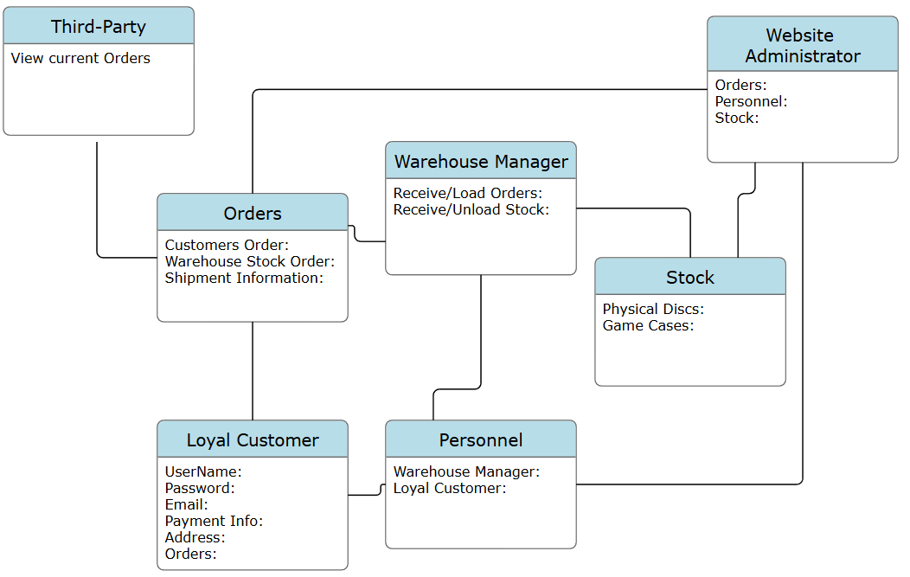
This Class diagram depicts how the objects represent each actor in the process of the Steam Ordering System. The Website Administrator is responsible for the customers orders, maintaining the stock of the warehouse, and issuing orders to be completed to the Warehouse manager. This is represented with the Personnel tab, which depicts the personnel involved in the interaction. The Customer has login information, as well as orders they place to be reviewed by the Website Administrator, and placed by the Warehouse Manager. The Warehouse Manager receives the orders, reports the stock of goods to the Website Administrator, and receives and sends orders of Stock. A third party has the ability to view the orders placed by the company and clients.

Section 4: Sequence and Collaboration Diagram
Sequence and collaboration diagrams are both amazing UML models that the Steam Order Catalog utilizes in order to communicate the process of tasks. The sequence diagram focuses on the timeline of a given task. The collaboration diagram focuses on the relationships between each of the objects. The following 2 diagrams represent the sequence diagram and collaboration diagram for the Customer, Catalog and Database. The diagrams focus on the Use case of a customer logging into the site, browsing and placing orders, and getting a confirmation of the order.
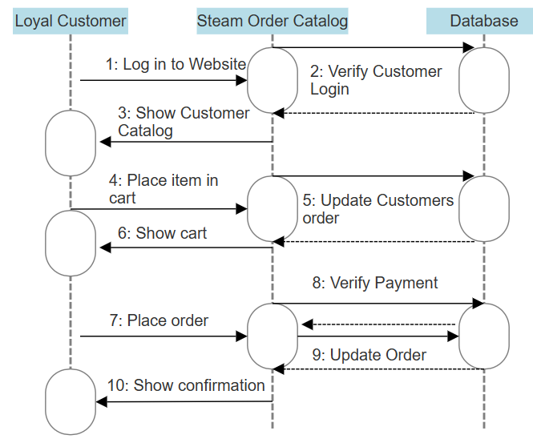
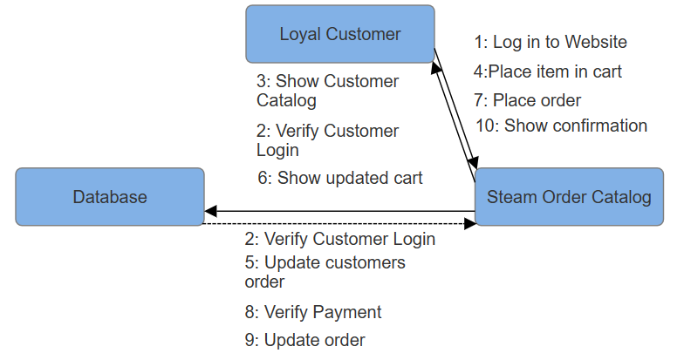
The next sequence and collaboration diagrams focus on the interactions of the Website Administrator, Database, and Warehouse manager. This process described by these models goes through the Website Administrator maintaining inventory and verifying customer orders. It also displays the processes the Warehouse manager undergoes in order to keep track of stock, updating the database and staging customer orders for delivery.
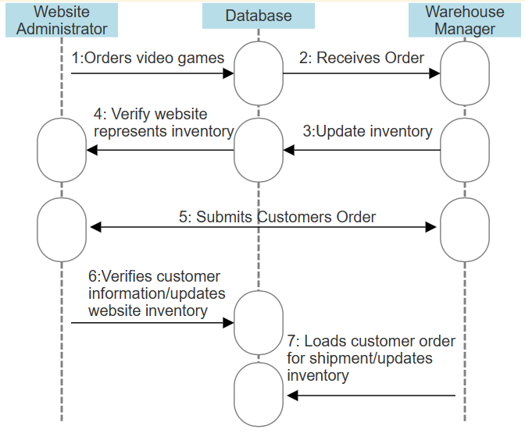
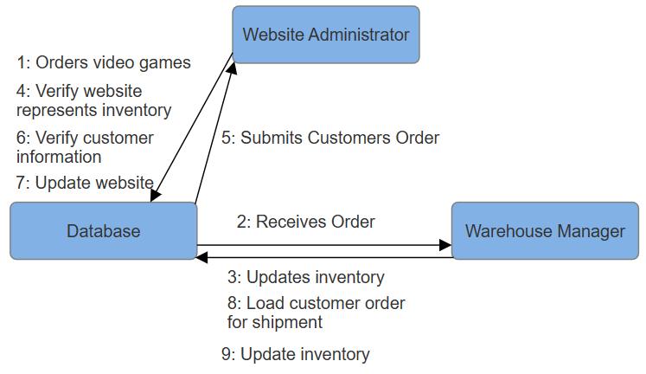
With these diagrams showing all of the potential interactions of the actors and their use cases, it is easy to communicate to all teams what exactly is needed. Development knows how to code and manage the database. Stakeholders understand the functionality of the system and what it will provide. And customers know what to expect when operating the website.

Section 5: State Transition and Activity Diagram
The State Transition diagram for the process of logging into the web store is fairly straightforward. A state transition diagram has an initial state and a final state with the different positions one may find themself in throughout the process. This shows how the user will start with logging in, potential errors they may find by entering incorrect information, and the final state where they successfully log in to the order catalog.
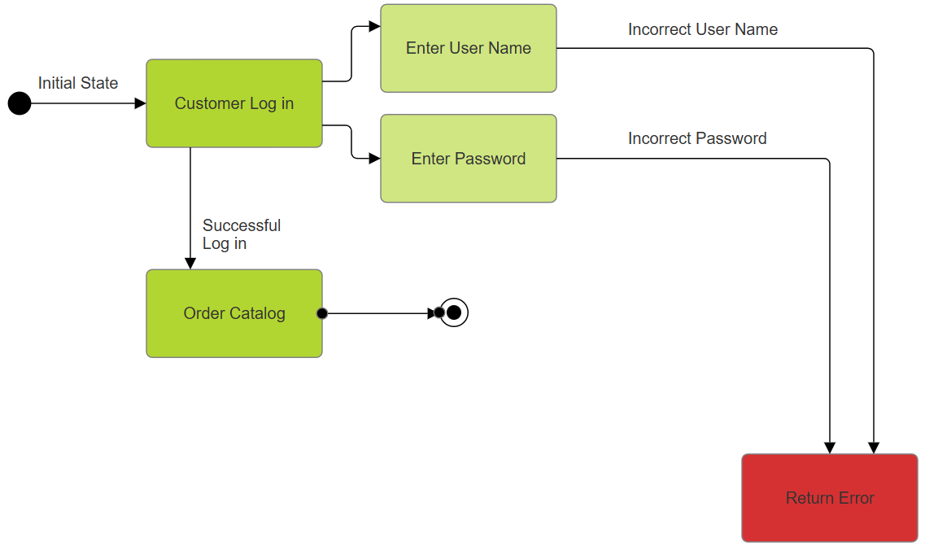

This state transition diagram depicts the ordering process for the customer. They start with viewing the catalog, placing or removing items from the cart to update them, then review the cart. Once they are satisfied they can place the order. They may enter invalid payment information, which would return an error. Once they validate the payment, the order is placed for shipment.
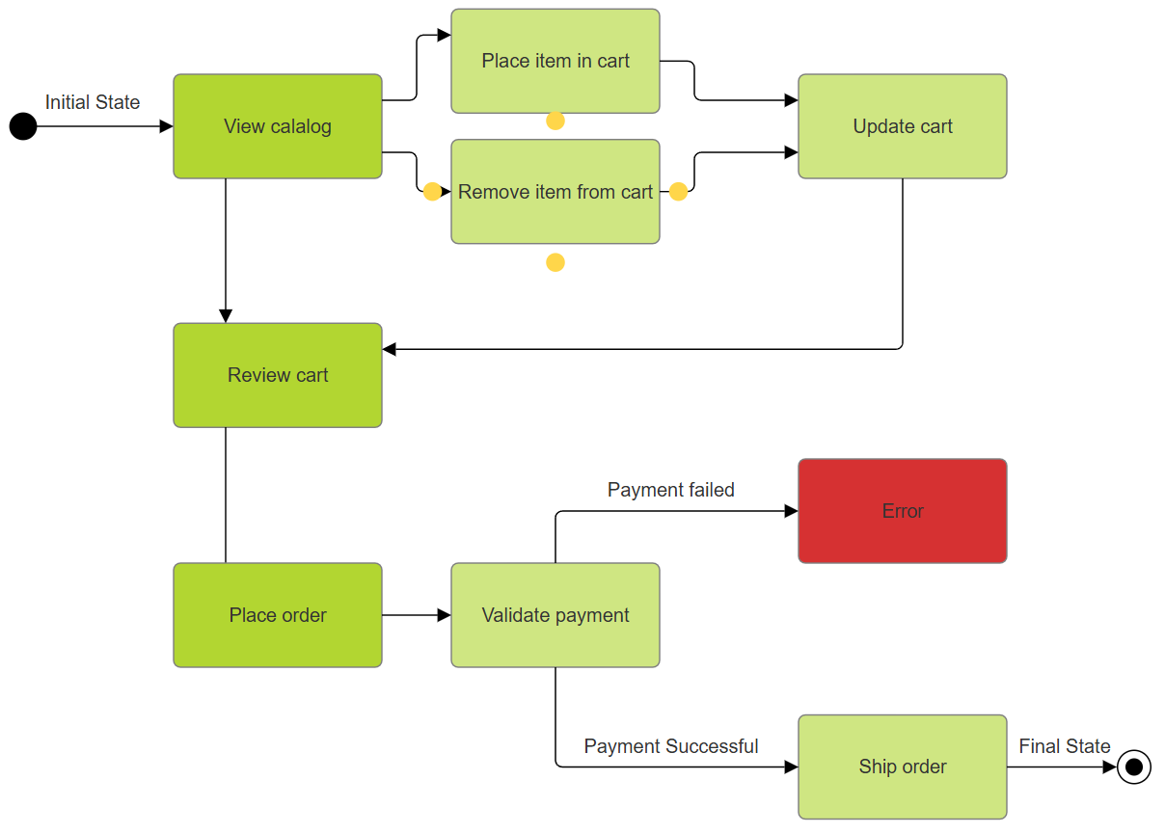

The following activity diagram illustrates the different activities the website administrator is responsible for while managing orders. The orders for both updating warehouse stock and managing customer orders are shown in two different paths, each of which end in the final state.

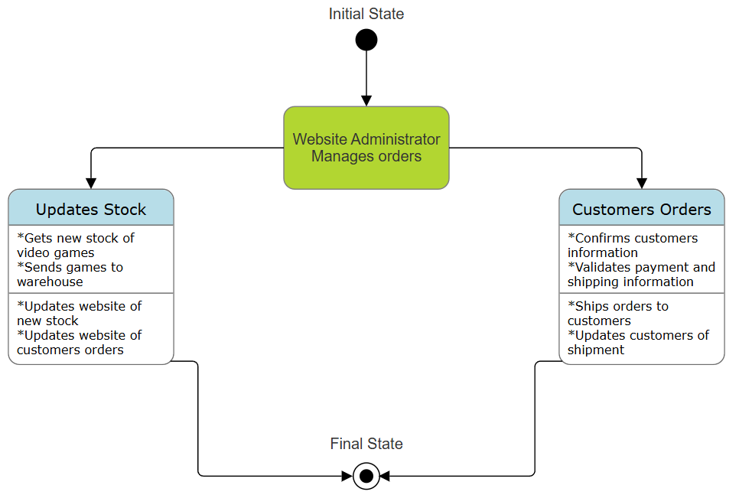

The last activity diagram shows the process of the warehouse manager receiving and sending shipments of orders. Maintaining the warehouse's stock and updating the website administrator, and staging the customers orders both end in the final state.
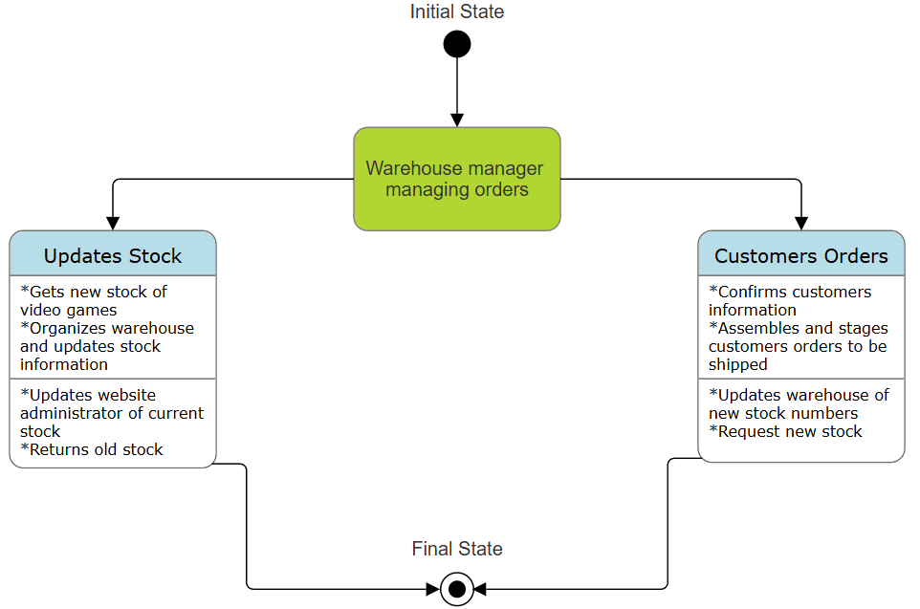

Section 6: Follow-up Discussion on Use of Object-Oriented and Recap of Design Changes
Focusing with the lens of Object Oriented methods greatly helps create all kinds of different software successfully. The ideology of having each component represented by an object, what those objects do and how they interact together creates a complete picture of what needs to be implemented and how to do so. With the UML diagrams, they help flush out certain situations the software may experience. This helps with preventing unwanted errors to occur, and anticipate how the software will respond with what the users are trying to use the software for in the first place.
The Use case diagram is essential for describing the whole of a system and it’s parts. Establishing this early on in a project greatly reduces the need to backtrack and rework already established code and designs. The Class diagram helps further this goal by almost creating a pseudo code for developers to create classes and attributes for each object to inherit. The Sequence and Collaboration diagrams help to understand the flow of the project depending on the use case. These diagrams explain how each part of a system undertakes a given task over a certain period of time. The importance of these diagrams is to display how each part works with another, achieving the softwares ultimate goal in a given situation. State transition diagrams help the design and development teams to understand how things need to move from one state to the next, and how to handle each potential error or successful action taken by a user. And lastly, the Activity diagram helps illustrate the actions each party makes and the responsibilities they have as a part of the software.

Section 7: Change Control Document
Many changes were made in order to establish a third party's abilities to review orders. The changes are documented in the following:
- Use Case Diagram
  - Page 4
  - Changes the document by adding an additional actor to the Use Case diagram and creating an order log for review by a third party.
- Text Addition
  - Page 5
  - Text has been added to describe the Use Case diagrams addition of a third party and its order viewing ability.
- Class Diagram
  - Page 6.
  - Changes the Class diagram by adding a third party with an attribute to view orders.
- Text Addition
  - Page 6
  - Text has been added to describe a third party’s relation to viewing orders.
- Text Alteration
  - Page 6
  - Grammatical errors were corrected to make the document a more clean and concise document

Resources
Steam, The Ultimate Online Game Platform (steampowered.com)
SmartDraw Dashboard
Warehouse Process Flow: The Warehouse Management Process (bluecart.com)
Class Diagram | Unified Modeling Language (UML) - GeeksforGeeks
Class Diagram: Examples, How to Make, Symbols, Benefits - Venngage
Collaboration Diagrams | Unified Modeling Language(UML) - GeeksforGeeks
State Transition Diagram for an ATM System - GeeksforGeeks
Activity Diagrams | Unified Modeling Language (UML) - GeeksforGeeks

